# 

# 

# **EQUITY ANALYSIS OF KPIGREEN**

Project Report:

Stock Market Simulation

Bachelor of Technology in CSE

Submitted by:

ABHINAV SAI REDDY KASU

**PAARI SCHOOL OF BUSINESS**

**SRM UNIVERSITY, AP**

**ANDHRA PRADESH – 522 540**

**DECEMBER – 2024.**

**CERTIFICATE**

This is to certify that the bachelor project report titled **“**Equity analysis of **KPIGREEN”** submitted for the award of the degree of **Bachelor of Technology** by **MR. K.ABHINAV(Register Number: AP 23110011568)** is the original work produced by him/her in the Paari School of Business, SRM University during DECEMBER 2024 under the guidance of Dr. Veeravel. V. The commitment and work shown by the student during the course were satisfactory.

The project report is a record of independent research work undertaken by him under my supervision and guidance and it has not previously formed the basis for the award of any Degree, Diploma, Associateship, and Fellowship to any University/College/Institution.

  Signature of the Faculty

Date:

**Table of Contents**

|  |  |  |
| --- | --- | --- |
| Certificate | | i |
| List of Tables | | ii |
| List of Figures | | iii |
| Abstract | | iv |
| **Chapter- I** | **Introduction** |  |
| 1.1 | Introduction |  |
| 1.2 | Statement of the problem |  |
| 1.3 | Objectives of the study |  |
| 1.4 | Scope of the study |  |
| 1.5 | Need for the study |  |
| 1.6 | Limitations of the study |  |
| 1.7 | Data and Methodology |  |
| 1.8 | Structure of the Project |  |
| **Chapter - II** | **Profile of the Company** |  |
| 2.1 | Introduction- About the Company |  |
| 2.2 | Objectives, Vision, and Mission |  |
| 2.3 | Management Structure (Board of Directions) |  |
| 2.4 | Nature of the Business |  |
| **Chapter - III** | **Equity Analysis** |  |
| 3.1 | Introduction to Equity Analysis |  |
| 3.2 | Fundamental Analysis |  |
| 3.3 | Technical Analysis |  |
| **Chapter - IV** | **Data Analysis and Interpretation** |  |
| 4.1 | Introduction |  |
| 4.2 | Financial Statements (Balance Sheet, Income Statement, Cash Flow Statement, and Ratios) |  |
| 4.3 | Significance of financial analysis |  |
| 4.4 | Nature of ratio analysis |  |
| 4.5 | Managerial uses of ratio analysis |  |
| **Chapter - V** | **Summary of Findings, Suggestions and Conclusion** |  |
| 5.1 | Summary of Findings |  |
| 5.2 | Major Findings |  |
| 5.3 | Conclusion |  |

**LIST OF TABLES**

|  |  |  |
| --- | --- | --- |
| **Table No** | **Title of the table** | **Page No** |
|  |  |  |
|  |  |  |
|  |  |  |
|  |  |  |
|  |  |  |
|  |  |  |
|  |  |  |
|  |  |  |
|  |  |  |

**LIST OF FIGURES**

|  |  |  |
| --- | --- | --- |
| **Figure No** | **Title of the figures** | **Page No** |
|  |  |  |
|  |  |  |
|  |  |  |
|  |  |  |

**ACRONYMS**

|  |  |
| --- | --- |
| BSE | Bombay Stock Exchange |
| EMH | Efficient Market Hypothesis |
|  |  |

**CHAPTER – I**

**1. Introduction**

**1.1 Introduction**  
Explains financial statements as essential tools for understanding a company's financial condition. Emphasizes the importance of ratio analysis in evaluating liquidity, solvency, and profitability, specifically for renewable energy businesses like KPI Green. Highlights the necessity of interpreting financial data to aid strategic decisions.

**1.2 Statement of the Problem**  
Addresses challenges in understanding KPI Green’s financial performance due to:

* Complex renewable energy market dynamics.
* Insufficient public analysis of its financials.
* The need for stakeholders to understand long-term viability amidst competition.  
  Focuses on evaluating KPI Green’s operational strengths, investment potential, and equity performance to form a clearer future outlook.

**1.3 Objectives of the Study**

* To analyze KPI Green's financial operations and sustainability.
* To assess its profitability and equity performance.
* To examine the company’s investment potential.
* To deliver actionable insights for stakeholders and investors.

**1.4 Scope of the Study**  
Concentrates on the financial and operational analysis of KPI Green, considering five years of historical financial data. Offers insights into its business model, contribution to renewable energy, and competitive positioning within the industry.

**1.5 Need for the Study**  
Highlights the importance of this study in understanding KPI Green’s contribution to sustainable energy, aiding stakeholders in making informed decisions. It emphasizes the growing relevance of renewable energy solutions in combating climate change and sustaining economic growth.

**1.6 Limitations of the Study**

* Availability of data: Limited disclosures and potential access issues with proprietary information.
* Market dynamics: Rapid changes in the renewable energy sector might impact long-term projections.
* Analytical constraints: Difficulty in benchmarking due to KPI Green's niche positioning.

**1.7 Data and Methodology**

* **Data Sources:** Includes primary data (interviews, surveys) and secondary data (financial reports, regulatory filings, industry benchmarks).
* **Methods:** Combines qualitative analysis of business operations and quantitative techniques like ratio analysis, trend analysis, and peer comparisons. Data is visualized using charts and statistical tools for clear interpretation.

**1.8 Structure of the Project**  
The project is organized into the following sections:

* Title Page
* Table of Contents
* Certificate
* Abstract
* Introduction
* List of Tables and Figures
* Acronyms
* Conclusions
* References

**Chapter- II**

**Profile of the Company**

**2.1 Introduction -About the company:**

KPIGREEN as an attention to detail organization is active in the production of ecological solutions and energy preparation systems based on sustainable and renewable energy technologies. The company aims to promote new green energy technologies and facilitate the global energy transition toward a sustainable future.

The organization and its clients’ energy projects and programs ty out in various regions allow KPIGREEN to offer a considerable assortment of products and services provided for the needs of solar, wind and other, currently emerging sources of renewable energy. Its main objective includes reduction of carbon footprints, enhancement of energy efficiency and promotion of sustainable practices and processes in businesses and communities.

**Competitors:**

Adani Green Energy Ltd.

Ind Renewable Energy Ltd.

KKV Agro Powers Ltd.

Ravindra Energy Ltd.

Tata Power Renewable Energy Ltd.

Renew Power Ltd**.**

**2.2 Our Purpose, Vision, and Mission:**

* **Vision:** To be a global leader in the renewable energy sector, pioneering innovative solutions that empower sustainable development.
* **Mission:** To deliver high-quality, eco-friendly energy solutions while contributing to a carbon-neutral planet.

Whether it's through solar panel installations, wind energy farms, or smart energy management systems, KPIGREEN is committed to making renewable energy accessible and reliable for all.

**2.3 Management Structure (Board of directors):**

1. **Dr. Faruk G. Patel** – Chairman & Managing Director. He is the founder and visionary behind the company and has significantly contributed to its growth across various business sectors like Solar, Wind, Hybrid, and Green Hydrogen Ammonia​

1. **Mr. Moh. Sohil Yusufbhai Dabhoya** – Whole Time Director

The board also includes several independent and non-executive directors, such as:

* **Mrs. Venu Birappa**, Independent Director
* **Mrs. Bhadrabala D. Joshi**, Non-Executive Director
* **Mr. Mohamed Hanif Mohamed Habib Dalchawal**, Independent Director
* **Mr. Shanker Baheria**, Independent Director
* **Dr. Tejpalsingh Jagatsingh Bisht**, Independent Director
* **Mr. Amitkumar S. Khandelwal**, Non-Executive Director

Other key members of the management team include:

* **Dr. Alok Das**, Group CEO
* **Mr. Salim Suleman Yahoo**, Chief Financial Officer
* **Mr. Shaheedul Hasan**, Chief Operating Officer
* **Mr. Manish Sayata**, Chief People Officer​

**2.4 Nature of the Business: KPI Green Energy Limited**

KPI Green Energy Limited specializes in renewable energy, primarily focusing on solar power generation. The company operates as both an **Independent Power Producer (IPP)** and a **Captive Power Producer (CPP)**. Its core activities include:

1. **Solar Power Plant Development:**
   * Developing, constructing, and operating utility-scale solar power plants for electricity generation.
2. **Captive Power Projects:**
   * Providing customized solar energy solutions for industrial and commercial clients, enabling them to meet their power needs sustainably and cost-effectively.
3. **Solar Infrastructure and Parks:**
   * Establishing and managing solar parks, offering ready-to-use solar infrastructure for clients.
4. **Renewable Energy Solutions:**
   * Exploring hybrid renewable technologies, including solar and wind, and venturing into green hydrogen production.

KPI Green Energy plays a vital role in promoting clean energy solutions and sustainability, aligning with global environmental and energy efficiency goals.

**CHAPTER - III**

**Equity Analysis:**

**3.1 Introduction to Equity Analysis**

Equity analysis involves evaluating sectors and companies to recommend stock purchases to investors, fund managers, and stakeholders. For KPI Green Energy, equity analysis provides insights into the company’s operational efficiency, growth potential, and position within the renewable energy sector.

This analysis involves examining financial performance, industry trends, and economic factors to understand the company’s valuation and risks. By combining **quantitative metrics** and **qualitative insights**, equity analysts aim to guide investors in making well-informed decisions regarding KPI Green’s stock performance.

The process typically includes the following phases:

1. **Preparatory Phase:** Gathering data about KPI Green’s operations, market conditions, and financial metrics.
2. **Review and Analysis Phase:** Assessing the potential impact of strategic decisions, regulatory changes, and market trends on the company.
3. **Risk Management and Opportunities:** Identifying opportunities to enhance growth and mitigate risks associated with renewable energy projects and policy changes.

Key elements of equity analysis for KPI Green include:

* **Company Analysis:** Evaluation of KPI Green’s business model, operational efficiency, and competitive strengths

**. Industry Analysis:** Reviewing the renewable energy sector, including demand for solar energy, government incentives, and competitors.

* **Economic Analysis:** Considering macroeconomic trends like energy transition policies, climate goals, and carbon pricing.
* **Risk Assessment:** Addressing project financing risks, policy uncertainties, and competition.

**3.2 Fundamental Analysis**

Fundamental analysis evaluates KPI Green’s intrinsic value based on its financial performance, operational strengths, and market potential. This method helps investors determine whether the company's stock is undervalued or overvalued.

For KPI Green:

1. **Economic Analysis:**
   * Review India’s renewable energy policies, tax benefits, and government incentives for solar and hybrid projects.
   * Assess global energy trends like the adoption of solar power and carbon reduction goals.
2. **Industry Analysis:**
   * Examine the demand for solar parks and captive power projects in the industrial sector.
   * Evaluate competitors’ market share and strategic investments.
3. **Company Analysis:**
   * Analyse KPI Green’s revenue streams from **IPP (Independent Power Producer)** and **CPP (Captive Power Producer)** models.
   * Assess the company’s profitability through metrics like net profit margin and return on equity.

If KPI Green’s intrinsic value exceeds its current stock price, the stock may be a good buy. Conversely, if the stock is priced higher than its intrinsic value, selling may be advisable.

**3.3 Technical Analysis**

Technical analysis for KPI Green involves studying historical price patterns and volume trends to predict future stock movements. This approach is valuable for short-term traders and investors looking to optimize entry and exit points.

**How technical analysis works for KPI Green:**

* **Chart Patterns:** Analyze price trends and chart structures (e.g., resistance and support levels) to identify growth phases or corrections.
* **Market Sentiment:** Monitor trading volumes and price breakouts to gauge investor sentiment toward renewable energy stocks.
* **Risk Management:** Use support and resistance levels to set stop-loss and take-profit points.

For KPI Green, the stock price trends may reflect factors such as:

* New solar project announcements or successful execution.
* Changes in government renewable energy policies.
* Financial performance indicators like quarterly results or expansions.

By combining **technical indicators** like moving averages and RSI (Relative Strength Index) with historical price data, traders and investors can better predict KPI Green’s stock trajectory.

This equity analysis provides a structured approach to evaluating **KPI Green Energy Ltd.** and its potential as a sustainable investment option in the renewable energy sector.

**CHAPTER - IV**

**Data analysis and interpretation**

**4.1 Introduction:**

Data analysis is the backbone of modern business because it has enabled organizations to make a judgment rather than their gut feelings, and how it proceeds in the process; it contains the following key elements that end in the final delivery of deriving insights from data.

*Key steps involved in data analysis

**Data Collection:** Primary data relevant to the activity from different sources forms the input for effective analysis. It includes customer interaction, sales transaction, operations processes, or even external market data.

**Data Processing:** After collection of data, cleaning and organizing of data is required for accuracy and consistency. This is a very important step, as it removes errors and prepares data for proper analysis.

**Data Analysis:** Statistical and machine learning methods are used here to extract patterns and correlations and insights in the data. EDA is most widely used in this step to know what characteristics the data holds.

**Data Interpretation:** The interpretation of the result of the analysis produces meaningful insights that can be acted upon. This is basically the translation of complex findings in data into understandable conclusions for stakeholders.

**Decision Making:** The outcome of the analysis then used in strategic decisions in different business sectors, for instance, strategies of marketing, product development, and resource allocation.

**Continuous Improvement:** Last but not least, companies ought to monitor the outcome of decisions through data analytics then make adjustments at times since new data is always coming up.

**4.2 Financial Statements:**

**Balance Sheet:**

A balance sheet would be a statement reporting the firm's assets, liabilities, and equity.  
 One of the three fundamental statements used in evaluating a business is its balance sheet.  
 It states the financial position of a firm as of the publication date-whatever it owns and owes.  
 A balance sheet is that part of the financial statement of a company reporting the amount of assets, liabilities, and equity held by its shareholders at any given point in time. Balance sheets provide a basis for computing rates of return for investors and also evaluate a company.

In other words, a balance sheet is the financial statement that reveals in detail what a firm owns and owes and how much is invested by the shareholders. One may use balance sheets together with other important financial statements in order to make some kind of fundamental analysis or determine the financial ratio

**BALANCE SHEET:**

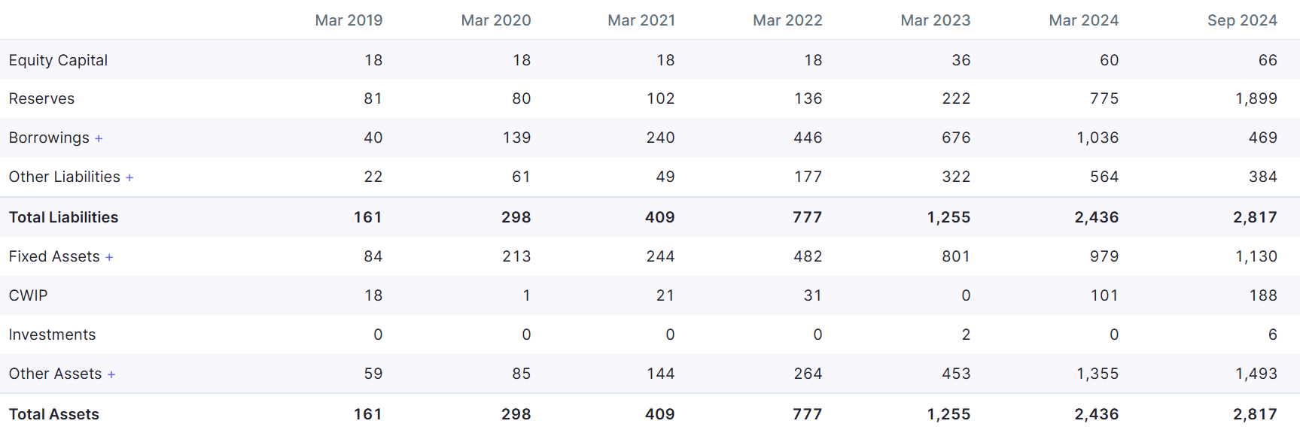

**Analysis:**

There was stable growth regarding both Assets and Liabilities over the period of analysis.

Debt Increase There is a steep increase in Borrowings, which implies reliance on debt finance.

Investment Focus There is deep investment evidence. The figure of "Investments" is relatively growing.

The build-up reserve is still growing and, thus, providing a sound financial position with potential for expansion in the future.

**Income statement:**

An income statement is the financial report of the business. It shows revenues, expenses, gains, and losses within a given period. The P&L statement, statement of revenue, and expense report an income statement. It might be very useful in reporting a company's activities, efficiency in managing operations, areas underperformance, and relative performance of such a company against other competitors.

The income statement is one of the three key financial statements issued to report the financial performance of a company over some set accounting period. Other two key statements are called the balance sheet and the cash flow statement.

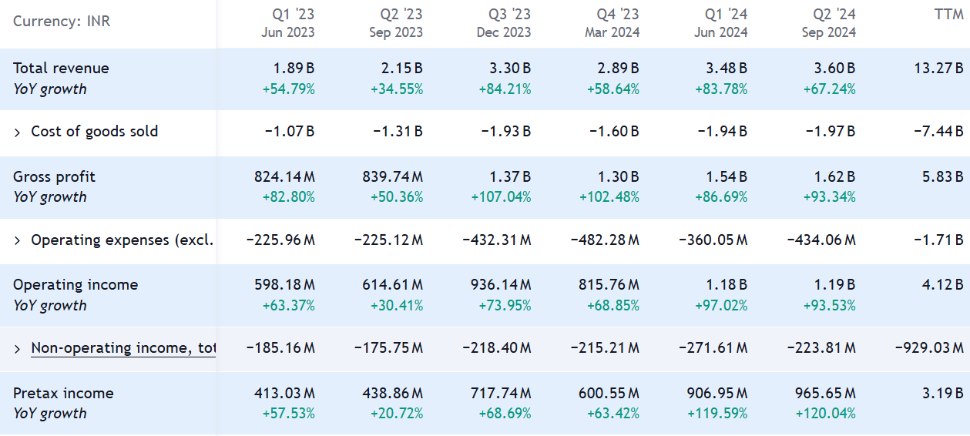**Analysis:**

Revenue Growth: The company has consistently increased its total revenue over the analysed period.

Profitability**:** Operating income/profit has also shown a positive trend, indicating improved profitability.

Expense Management: While operating expenses have increased, they have not outpaced revenue growth, contributing to the improved profitability.

**Cash flow statement:**

The cash flow statement paints a picture of how a company's operations are running, where its money comes from, and how money is being spent. Also referred to as the statement of cash flows, the CFS helps its creditors know how much cash is available—referred to as liquidity—for the company to fund its operating expenses and pay down its debts. The CFS is equally important to the investors because it tells them whether or not a company is based on solid financial ground. As such, they could use the statement to better, more informed decisions about their investment. A cash flow statement tracks the inflow and outflow of cash, so it provides insights into a company's financial health and operating efficiency.

CFS measures the effective management of a company in its cash position. Meaning, it measures how efficiently the company generates cash that will pay its debt obligation and funding of operating expense. It is one of the three major financial statements complemented by the balance sheet and income statement. In this article, we will illustrate how the CFS is structured and guide you on how to use it to analyse a company.

Cash Flows:

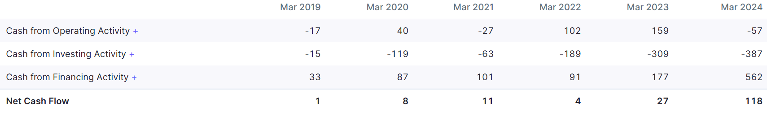

**Analysis:**

**Fluctuating Net Cash Flow:** The company's net cash flow has been fluctuating over the period, with both positive and negative years.

**Positive Operating Cash Flow:** Cash from operating activities has been consistently positive, indicating the company's ability to generate cash from its core operations.

**Negative Investing and Financing Cash Flows:** Both investing and financing activities have resulted in negative cash flows, suggesting significant capital expenditures and debt repayments.

**Ratios:**

The process of formulating financial ratios acquires numeric values from different forms of the financial statements and comes out with meaning information regarding the company. These figures are on the company's balance sheet, income statement, and the cash flow statement, amounting to quantifying an analysis of study aspects relating to some of the liquidity, leverage growth, margins, profitability rates of return, valuation of many other attributes of a firm.

There are three broad categories of financial ratios, namely

* Liquidity Ratios
* Leverage ratios
* Efficiency Ratios
* Profitability Ratios
* Market Value Ratios

**RATIOS: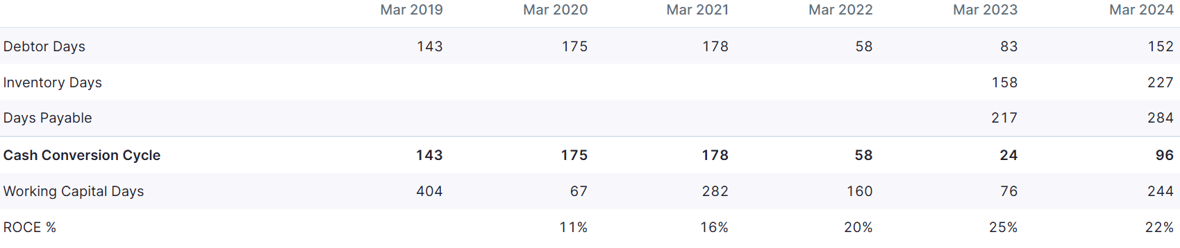Analysis:**

Improving Efficiency: The company has shown a consistent effort to improve its efficiency, as evidenced by the decreasing Cash Conversion Cycle and Working Capital Days.

Declining Profitability: The ROCE (Return on Capital Employed) has been declining over the years, indicating a decrease in profitability.

**4.3 Significance of Financial Analysis:**

**Analysing past performance:** it indicates future prospects for a firm based on its earlier performances. Analysing the past involves reviewing the trend in past sales, profitability, cash flow, return on investments, a structure of debt to equity, among others concerning operating expenditures. It judges the present position & operating efficiency. It examines the current profitability & operational efficiency of the enterprise so that the financial health of the company can be determined. Assets & liabilities of the company are reviewed for long-term decision making. Analysis helps find out the earning capacity & operating performance of the company.

**Prediction of growth & profitability prospects:** The top management is concerned with the future prospects of the company. Financial analysis helps them in reviewing the investment alternatives for judging the earning potential of the enterprise. With the help of financial statement analysis, assessment and prediction of the bankruptcy and probability of business failure can be done.

**Loan Deciding by Financial Institution and Bank:** With financial analysis, the financial institution, loan agency & banks decide whether to sanction a loan to a company or not. This also helps the financial institution decide terms and conditions in case the loan is sanctioned; interest rates and the date for maturity etc.

**4.4 Nature of Ratio Analysis:**

Ratio Analysis Types of Ratios

The financial ratios available can broadly be categorized into six types according to the kind of data that they provide. Using each category of ratios will give a view of the company in multiple dimensions and help you notice some red flags.

**1. Liquidity Ratios**: Liquidity ratios determine the firm's capability to pay short-term debts when these falls due by using the firm's current or quick assets. Liquidity ratios include:

* Current Ratio
* Quick ratio
* Working capital ratio:

**2. Solvency Ratios:** Financial leverage ratios, as they're also called, are comparisons of a business's debt to its assets and equity, earnings, and other accounts. These ratios measure a company's probability of having a long-term existence within which to service long-term debt as well as pay interest upon that debt. Examples of this include:

* Debt-equity ratio
* Debt-to-assets ratio
* Interest coverage ratio

**3.Profitability Ratios:** These are ratios that explain how a company is able to generate profits from its operations. Examples of profitability ratios include:

* Profit margin ratio
* Return on Assets
* Return on equity
* Return on capital employed
* Gross margin ratio

**4. Liquidity Ratios**

Also known as activity ratios, efficiency ratios measure the effectiveness of a company in using its assets and liabilities to generate sales and improve profitability. Some key efficiency ratios are:

* Turnover Ratio
* Inventory Turnover
* Days' sales in inventory

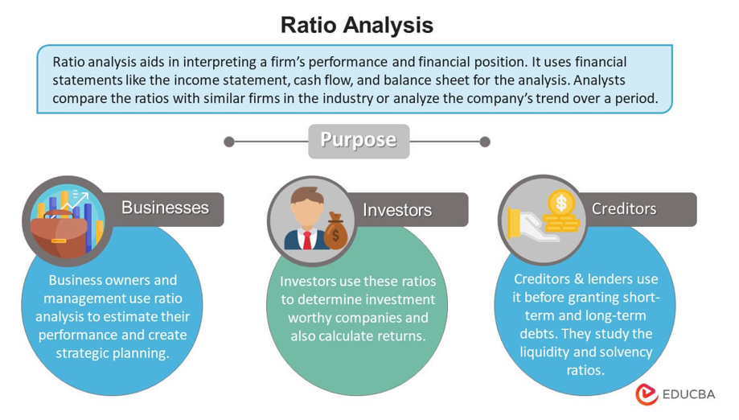**5. Coverage Ratios**

Coverage ratios represent the ability of a firm to meet the interest and other obligations in debts. These include:

* Times interest earned ratio
* Debt-service coverage ratio

**6. Market Prospect Ratios:**

Market prospect ratios are the most available fundamental analysis ratios. The investors compare these metrics in predicting earnings and future performance. These ratios include:

* Dividend yield P/E ratio Earnings per share,
* EPS Dividend payout ratio

**4.5 Managerial uses of ratio analysis:**

The manager uses ratio analysis in knowing how the company is performing in terms of finance over time. It can be applied in identifying strengths and weaknesses for purposes of formulating strategies and initiatives. This will facilitate measurement of profitability and a firm's operating efficiency. This method proves effective in the evaluation of the short-term financial standing of a firm. Enables to identify future trends of business and subsequently helps formulate an effective budget

• Ratio Analysis for Managerial Purpose Financial Performance For the computation of profitability such as: the net profit margin, ROA return on assets or ROE return on equity, managers can assess the company's ability of making profits in proportion to its sales or its shareholders' equity or total assets. The Measure of short-term assets and liabilities includes the current ratio and the quick ratio allowing managers to check and confirm if the company is likely to meet its short-term obligations effectively, thus ensuring smooth operations in the organization. Generally, DER is used as a measure to show the long-term financial soundness of the company as well as the capability to manage its debt properly.

• The analysis of operating efficiency included: Activity ratios, which are composed of: Inventory turnover, accounts receivable turnover: accounts payable turnover in case of variables. They monitor the use of resources, including inventory and receivables and examine how these resources are utilized efficiently. Reflects how effectively a company can employ its assets to make sales or revenue.

•Comparison with Benchmark performance review evaluation plausibility and comparisons of the given benchmark by like Industry mean or the historical performance to achieve Competing benchmark financial ratio analysis to department, to meet specific departments' operations/functional ratios exclusively department-based project-specific.:.

• Setting department or even worker specific financial goals. Determining the return on investment (ROI) regarding capital to choose which investment opportunities to concentrate on. This type of ratios can be helpful for leverage ratio when deciding on potential decisions regarding capital, and also investment requirements.

**Chapter V**

**Summary of Findings, Suggestions, Conclusion**

**5.1 Summary of Findings: Financial Performance Analysis**

1. **Importance of Financial Statements**
2. Financial statements are critical for evaluating KPI Green Energy's financial health, providing clarity on its operational performance and market competitiveness. They are a foundation for conducting ratio analysis, aiding stakeholders in identifying strengths and areas for improvement.
3. **Ratio Analysis**

The analysis covers key performance metrics:

* 1. **Profitability:** Evaluates how efficiently the company generates earnings relative to revenue.
  2. **Liquidity:** Assesses the ability to meet short-term obligations.
  3. **Solvency:** Determines long-term financial stability and capability to fulfill debt obligations.

1. **Market and Equity Value Drivers**
   1. Identifies competitive positioning within the renewable energy sector.
   2. Examines strategic factors such as investment in green technologies and infrastructure that influence market valuation.
2. **Strategic Insights**

Provides stakeholders with actionable insights to strengthen financial performance and resource allocation, addressing market volatility and navigating intricate financial landscapes.

**Company Overview**

1. **Background**

KPI Green Energy operates in the renewable energy sector, focusing on solar energy projects and clean power generation. It contributes to sustainable energy solutions, emphasizing environmental impact reduction.

1. **Mission and Vision**

The company aims to lead in renewable energy innovation while providing sustainable solutions and fostering long-term growth.

1. **Organizational Structure**

A leadership team committed to strategic expansion and technological innovation guides the organization.

**5.2 Major Findings**

1. **Financial Health Assessment** KPI Green Energy's financial reports highlight robust profitability, efficient liquidity management, and strong solvency. These aspects underline its resilience and capacity to sustain operations in a competitive market.
2. **Ratio Analysis**
   1. **Profitability:** Demonstrates efficient revenue generation and operational excellence.
   2. **Liquidity:** Indicates readiness to manage short-term liabilities, ensuring operational continuity.
   3. **Solvency:** Reflects the company's capability to handle long-term financial commitments.
3. **Market Position and Equity Value**

The company leverages strategic initiatives in solar and green energy, maintaining a competitive edge and increasing its market valuation.

1. **Strategic Insights**

Suggests the importance of adopting advanced financial tools and performance measurement systems to address market challenges and complex operations.

1. **Challenges**
   1. Managing fluctuating energy policies and market conditions.
   2. Balancing high capital investment in innovative technologies with sustainable profitability.

**5.3 Conclusion**

KPI Green Energy exhibits strong financial fundamentals, ensuring profitability, liquidity, and solvency. Its focus on renewable energy aligns with global trends, securing its market position. The company’s emphasis on innovation and sustainability underscores its growth potential and industry leadership.

**Key Recommendations**

1. **Strengthen Financial Reporting:**

Simplify and enhance the clarity of financial disclosures to support stakeholders' decision-making.

1. **Invest in Technological Innovation:**

Continue focusing on advanced renewable technologies, including expanded solar projects and energy storage systems.

1. **Policy and Market Adaptability:**

Develop strategies to mitigate the impact of regulatory changes and market fluctuations on operations.

1. **Sustainability Initiatives:**

Promote sustainable practices and capitalize on government incentives for green energy projects to drive growth.

**References:**

[**https://www.vedantu.com/commerce/accounting-ratios**](https://www.vedantu.com/commerce/accounting-ratios)

[**https://www.investopedia.com/terms/r/ratioanalysis.asp**](https://www.investopedia.com/terms/r/ratioanalysis.asp)

[**https://www.google.com/**](https://www.google.com/)

[**https://www.wikipedia.org/**](https://www.wikipedia.org/)

[**https://www.google.com/search?sca_esv=41165fec71bc817d&rlz=1C1CHZN_enIN1084IN1084&q=nature+of+ratio+analysis&source=lnm**](https://www.google.com/search?sca_esv=41165fec71bc817d&rlz=1C1CHZN_enIN1084IN1084&q=nature+of+ratio+analysis&source=lnm)

[**https://www.toppr.com/guides/accountancy/analysis-of-financial-statements/meaning-significance-objectives-financial-analysis/**](https://www.toppr.com/guides/accountancy/analysis-of-financial-statements/meaning-significance-objectives-financial-analysis/)

[**https://corporatefinanceinstitute.com/resources/accounting/financial-ratios/**](https://corporatefinanceinstitute.com/resources/accounting/financial-ratios/)

[**https://www.investopedia.com/investing/what-is-a-cash-flow-statement/**](https://www.investopedia.com/investing/what-is-a-cash-flow-statement/)

[**https://www.scribd.com/document/97509893/Balance-Sheet-of-Hero-Motocorp**](https://www.scribd.com/document/97509893/Balance-Sheet-of-Hero-Motocorp)

[**https://www.screener.in/company/HEROMOTOCO/consolidated/#ratios**](https://www.screener.in/company/HEROMOTOCO/consolidated/#ratios)

[**https://www.google.com/search?sca_esv=41165fec71bc817d&rlz=1C1CHZN_enIN1084IN1084&q=balance+sheet+of+hero+motocorp&udm=2**](https://www.google.com/search?sca_esv=41165fec71bc817d&rlz=1C1CHZN_enIN1084IN1084&q=balance+sheet+of+hero+motocorp&udm=2)

**LIST OF TABLES**

|  |  |  |
| --- | --- | --- |
| **Table No** | **Title of the table** | **Page**  **No** |
|  |  |  |
|  |  |  |
|  |  |  |
|  |  |  |
|  |  |  |
|  |  |  |
|  |  |  |
|  |  |  |
|  |  |  |

**LIST OF FIGURES**

|  |  |  |
| --- | --- | --- |
| **Figure No** | **Title of the figures** | **Page**  **No** |
|  |  |  |
|  |  |  |
|  |  |  |
|  |  |  |

**ACRONYMS**

|  |  |
| --- | --- |
| BSE | Bombay Stock Exchange |
| EMH | Efficient Market Hypothesis |